**Title of Applications: SQL ASSIGNMENT**

**Author: HEMAMALANI E**

**Created date: 04-04-2024**

**LastModified date: 04-04-2024**

**Reviewed by:**

**Reviewed Date:**

ASPIRE ASSIGNMENT

TABLE 1:

insert into Programmer values ("HEMA" , '2002-11-25','2024-10-1' ,'F' , 'JAVA' , 'ADVANCED' , 50000 );

insert into Programmer values ("JAYA" , '2005-09-29','2024-09-2' ,'F' , 'PYTHON' , 'BASIC' , 25000 );

insert into Programmer values ("HARI" , '2002-04-24','2024-08-3' ,'M' , 'JAVASCRIPT' , 'INTERMEDIATE' , 30000 );

insert into Programmer values ("SANGEETHA" , '1998-12-15','2024-07-4' ,'F' , 'PYTHON' , 'INTERMEDIATE' , 40000 );

insert into Programmer values ("VIGNESH" , '1998-12-10','2024-06-5' ,'M' , 'MYSQL' , 'ADVANCED' , 13000 );

select * from Programmer;

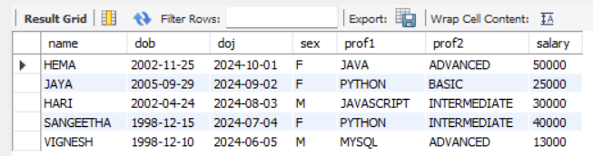

TABLE 2:

insert into software values("HEMA","EIGEN FACE FOR FACE RECOGNITION ","BASICS",50000,15000,25);

insert into software values("JAYA","ACCOUNT MANAGEMENT SYSTEM ","ADVANCED",80000,25000,29);

insert into software values("HARI","HAND WRITTEN DIGIT RECOGNITION ","INTERMEDIATE",40000,10000,24);

insert into software values("SANGEETHA","SECURING VEHICULAR COMMUNICATION","ADVANCED",80000,30000,15);

insert into software values("VIGNESH","ONLNE AUCTION SYSTEM ","ADVANCED",90000,45000,13);

select * from software;

TABLE 3:

create table studies (name varchar(25) , splace varchar(25) , course varchar(35),ccost varchar(25));

insert into studies values("HEMA","VILLUPURAM","CSE",25000);

insert into studies values("JAYA","CHENNAI","CSE",29000);

insert into studies values("HARI","MUMBAI","ECE",40000);

insert into studies values("SANGEETHA","HYDERABAD","CSE",50000);

insert into studies values("HEMA","BANGLORE","CSE",35000);

select * from studies;

QUERIES :

1. select avg(scost) from software WHERE dev_in="ADVANCED";

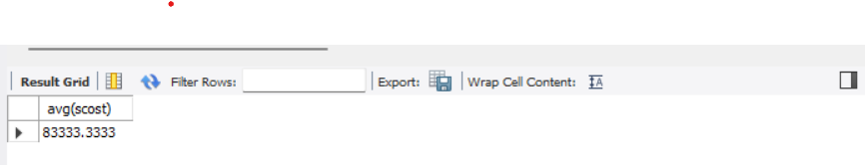

2.select name,dob from programmer;

--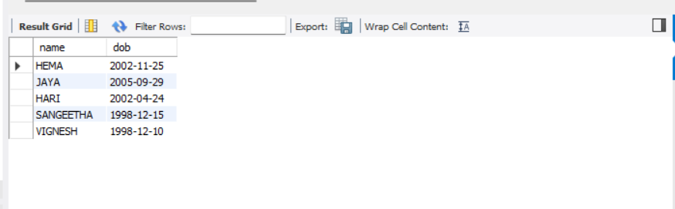

3.select name , dob from programmer where prof1="PYTHON";

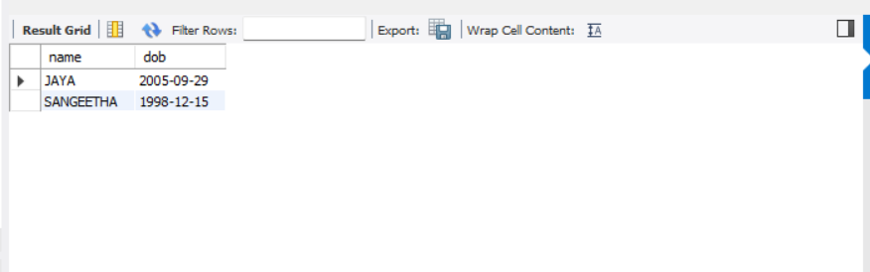

4. SELECT MAX(sold) AS max_sold

FROM software;

5. SELECT name, dob FROM Programmer WHERE MONTH(dob) = 1;

6. Display lowest course fee.

SELECT MIN(ccost) FROM studies;

7) How many programmer has done PYTHON course

select name,prof1 from programmer where prof1="PYTHON";

8) How much revenue has been earned through sales of packages in ADVANCED ?

SELECT SUM(scost*sold) AS total_revenue

FROM software

WHERE dev_in = 'ADVANCED';

9. ) Display the details of software developed by Hema .

select title ,dev_in,scost,dcost,sold from software where name="hema";

10) How many programmers studied at BANGLORE.

select name,course from studies where splace="BANGLORE";

11) Display the details of PACKAGES whose sales crossed the 20000 mark.

SELECT *

FROM software

WHERE scost >= 20000;

12) Find out the number of copies which should be sold in order to recover the development cost of each package.

SELECT name,dcost,scost,CEIL(dcost / scost) AS copies_required FROM software;

13) What is the price of the costliest software developed in BASIC?

Select * from sofTware WHERE dev_in ="BASICS";

14) Display the details of packages for which development cost has been recovered.

SELECT * FROM softwarE WHERE dcost <= scost;

15) How many packages were developed in dbase?

Select * from programmer WHERE prof1="PYTHON";Select * from programmer WHERE prof1="PYTHON";

16) How many programmers studies at paragathi?

SELECT name,studies_place

FROM studies

WHERE studies_place = 'paragathi';

SELECT COUNT(*)

FROM studies

WHERE studies_place = 'paragathi';

17) How many programmers paid 5000 to 10000 for their course?

SELECT COUNT(*)

FROM studies

WHERE course_cost BETWEEN 5000 AND 10000;

18) What is the average course fee?

SELECT AVG(course_cost)

FROM studies;

19) Display the details of programmers knowing c?

SELECT name,language1,language2

FROM programmer

WHERE language1 = 'c' OR language2 ='c';

20) How many programmers know either Cobol or Pascal?

SELECT COUNT(*)

FROM studies

WHERE language1 = 'Cobol' OR language2 ='Pascal';

SELECT name,language1,language2

FROM programmer

WHERE language1 = 'Cobol' OR language2 ='Pascal';

21) How many programmers don't know Pascal & C?

SELECT COUNT(*)

FROM Programmer

WHERE language1 NOT IN ('Pascal', 'C') && language2 NOT IN ('Pascal', 'C') ;

22) How old is the oldest male programmers?

SELECT MAX(age) AS oldest_age

FROM Programmer

WHERE sex = 'male';

23) What is the average age of female programmers?

SELECT name, age

FROM Programmer

WHERE sex = 'female'

AND age = (SELECT avg(age) FROM Programmer WHERE sex = 'female');

24) Calculate the experience in years for each programmers and display along with the names in descending order?

SELECT

name,

DATEDIFF(CURRENT_DATE, doj) / 365 AS experience_years

FROM

programmer

ORDER BY

experience_years DESC;

25) Who are the programmers who celebrate their birthday during the current month?

SELECT *

FROM programmers.programmer

WHERE MONTH(dob) = MONTH(CURDATE())

AND DAY(dob) = DAY(CURDATE());

26) How many female programmers are there?

SELECT COUNT(*)

FROM programmer

WHERE sex= 'female';

27) What are the languages known by the male programmers?

SELECT name, language1,language2

FROM Programmer

WHERE sex = 'male'

28) What is the Average salary?

SELECT SUM(salary) / COUNT(salary) AS average_salary FROM programmer;

29) How many people draw 2000 to 4000?

SELECT name,salary

FROM programmer

WHERE salary BETWEEN 2000 AND 4000;

30) Display the details of those who don't know Clipper, Cobol or Pascal?

SELECT name,language1,language2

FROM Programmer

WHERE language1 NOT IN ('Pascal', 'Cobol','Clipper')

&& language2 NOT IN ('Pascal', 'Cobol','Clipper') ;

31) How many Female programmers knowing C are above 24 years of age?

SELECT name, language1 ,language2

FROM programmer

WHERE language1 = 'c' AND age>24 AND sex='female';

32) Who are the programmers who will be celebrating their Birthday within a week?

SELECT *

FROM programmer

WHERE DATE_ADD(dob, INTERVAL YEAR(CURDATE()) - YEAR(dob) YEAR) BETWEEN CURDATE() AND DATE_ADD(CURDATE(), INTERVAL 7 DAY);

33) Display the details of those with less than a year's experience?

SELECT *

FROM programmers.programmer

WHERE DATEDIFF(CURDATE(), doj) < 365;

34) Display the details of those who will be completing 2 years of service this year?

SELECT *

FROM programmer

WHERE DATEDIFF(CURDATE(), date_of_joining) >= 365*2

AND DATEDIFF(CURDATE(), date_of_joining) < 365*3;

35) Calculate the amount to be recovered for those packages whose development cost has not been recovered?

SELECT

name, developmentcost, softwarecost,

(developmentcost - softwarecost) AS amount_to_be_recovered

FROM

software

WHERE

developmentcost > softwarecost;

36) List the packages which have not been sold so far?

SELECT MAX(sold) FROM software;

37) Find out the cost of the software developed by Mary?

SELECT name,softwarecost

FROM software

WHERE name = 'mary';

38) Display the institute’s names from the studies table without duplicates?

SELECT DISTINCT studies_place

FROM studies;

39) How many different courses are mentioned in the studies table?

SELECT DISTINCT course

FROM studies;

40) Display the names of the programmers whose names contain 2 occurrences of the letter A?

SELECT name

FROM programmer

WHERE name LIKE '%A%A%';

41) Display the names of programmers whose names contain unto 5 characters?

SELECT name

FROM programmer

WHERE LENGTH(name) <= 5;

42) How many female programmers knowing COBOL have more than 2 years experience?

SELECT name, language1, language2

FROM programmer

WHERE DATEDIFF(CURDATE(), doj) <= 365*2

AND sex = 'female'

AND (language1 = 'Cobol'

OR language2 = 'Cobol');

43) What is the length of the shortest name in the programmer table?

SELECT *

FROM programmer

WHERE LENGTH(name) = (SELECT MIN(LENGTH(name)) FROM programmer);

44) What is the average development cost of a package developed in COBOL?

SELECT AVG(developmentcost) AS average_developmentcost

FROM programmers.software

WHERE language_developed = 'COBOL';

45) Display the name, sex, dob (DD/MM/YY format), doj for all the programmers without using conversion function?

// string manipulation function

SELECT name, sex,

CONCAT(

SUBSTRING(dob, 9, 2), '/',

SUBSTRING(dob, 6, 2), '/',

SUBSTRING(dob, 3, 2)

) AS dob_dd_mm_yy,

CONCAT(

SUBSTRING(doj, 9, 2), '/',

SUBSTRING(doj, 6, 2), '/',

SUBSTRING(doj, 3, 2)

) AS doj_dd_mm_yy

FROM programmer;

46) Who are the programmers who were born on the last day of the month?

SELECT name, dob

FROM Programmer

WHERE dayofmonth(dob) = DAY(LAST_DAY(dob));

47) What is the amount paid in salaries of the male programmers who do not know Cobol?

SELECT name,salary

FROM Programmer

WHERE sex='male' AND(language1 NOT IN ('Cobol') AND language2 NOT IN ('Cobol')) ;

48) Display the title, scost, dcost and difference between scost and dcost in descending order of difference?

WHERE language_developed = 'COBOL';

SELECT title, softwarecost, developmentcost, (developmentcost-softwarecost ) AS cost_difference

FROM programmers.software

ORDER BY softwarecost DESC, developmentcost DESC;

49) Display the name, dob, doj of those month of birth and month of joining are same?

SELECT name, dob, doj

FROM programmer

WHERE MONTH(dob) = MONTH(doj);

50) Display the names of the packages whose names contain more than 1 word?

SELECT name

FROM programmer

WHERE LENGTH(name) > 1;